ROVanCO
20535 S.E. FRONTAGE ROAD
JOLIET, ILLINOIS 60431
PHONE: 815-741-6700
FAX: 815-741-9080
Email: chad@rovanco.com
Website: www.rovanco.com

Piping Systems, Inc.

October 7, 2025

Part 1 – General

1.01 Rhinoflex® Flexible, Pre-Insulated PEX Pipe for Hot Fluids up to 204ºF, intermittent 230ºF

1.02 The pre-insulated piping system must be of a flexible design, and all components of carrier pipe, insulation, and jacket must be able to expand and contract as a unit without overstressing or adversely affecting any of the materials. The pipe, insulation, and jacket will all be made of materials that will not corrode. The insulation shall completely fill the annular space between the service pipe and jacket and shall be completely bonded to both. The insulation must be polyurethane. Systems using open-cell insulation, polyethylene insulation, PEX insulation, or any non-bonded system, or partial-bonded system design shall not be allowed. The system will be designed to be installed in a manner that will not require expansion loops or compensators of any type. The system will be installed with the fewest number of underground joints possible. The piping system supplier will be responsible for the overall design of the expansion and contraction compensation. The system will be supplied complete with coupling fittings, insulation kits, and termination fittings all supplied by the piping system supplier. All products must be manufactured in the United States.
NSF certified 2” and under.

Part 2 - Products

2.01 Carrier Pipe: Cross-linked PEX-A pipe with EVOH (oxygen barrier Engel Method) for temperatures up to 204ºF. NSF 61 certified & ASTM F876 and F877 for all pipes ¾” – 2”. Pex-B and Pex-C products not allowed.

  - Insulation: All insulation materials will be supplied by the system manufacturer and will be
polyurethane closed cell insulation with a K-Factor of .149 The insulation will be furnished in the thickness as shown in Charts 1& 2 for the respective carrier pipe sizes. (3/4” heat trace PEX tube optional).

  - Jacketing Material: The outer protective jacket shall be corrugated seamless polyethylene
completely encompassing and protecting the insulation from moisture and damage, designed for H-20 loading at a burial depth of 2-ft minimum. The jacket will be provided in diameter and thickness as shown in Charts 1&2.

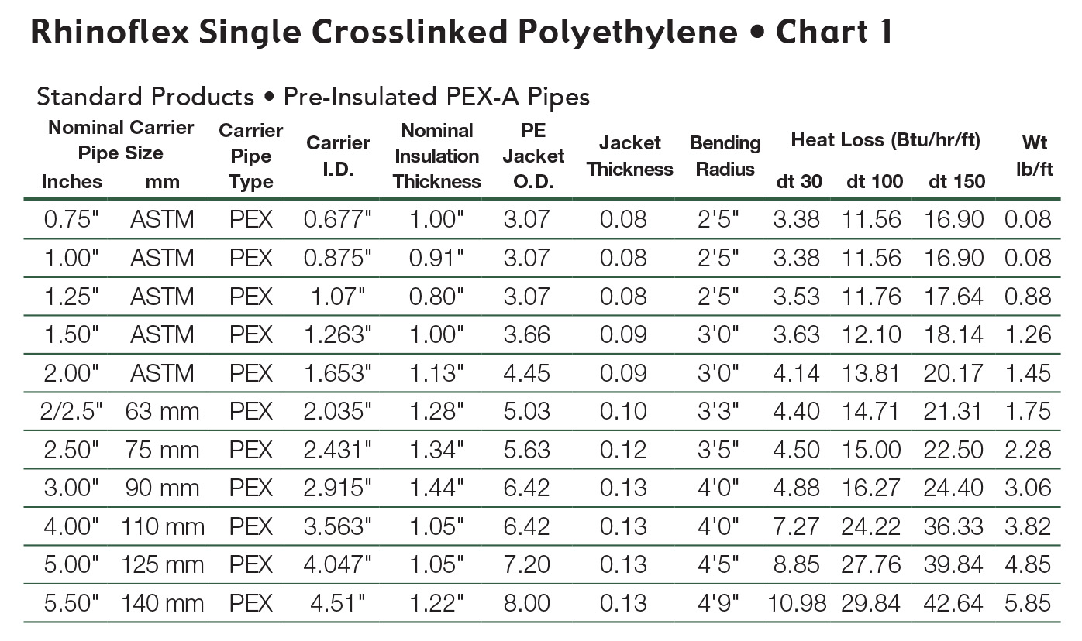
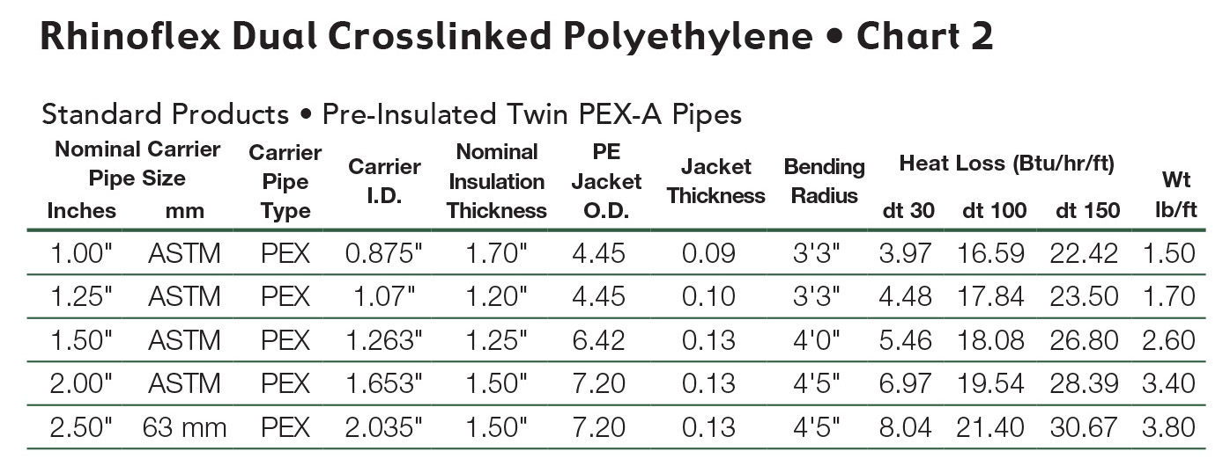

2.04 Fittings: All fittings and connections will be either- brass, copper, or steel. They will be installed in accordance with the detailed installation instructions. All buried fittings and couplings will be insulated and sealed per the system supplier's instruction. All fittings for potable to be ASTM & NSF Approved.

2.05 End Seals: All direct buried ends of insulated pipe with exposed insulation will be sealed with polyethylene or mastic end seals.

2.06 Manholes: The contractor has the option to supply field-built manholes or factory supplied polyethylene or coated steel manholes. If the system supplier is providing the factory engineered manholes, they will be installed per the supplier's instructions.

2.07 Field Tests: All carrier pipe systems should be hydrostatically tested at 1-1/2 times the operating pressure prior to burial.

2.08 Backfill: The pipe should be backfilled with clean fill a minimum of 4 inches on the trench bottom, 3 inches on either side, 2 inches between adjacent pipes and 6 inches over the top of the jacket. The balance of the trench can be filled in with native materials containing rocks no larger than 2 inches.

2.09 Supplier Assistance: At customer's request, system supplier will provide a qualified field service technician on-site to properly train the installing personnel in all phases of installation.

2.10 Approved Vendors: Rhinoflex, as supplied by Rovanco, Joliet, Illinois or approved equal. Any alternate supplier must submit their technical data to the engineer 20 days prior to bid date to be approved in writing as an equal.

2.11 Warranty: Rovanco does not approve of the practice of installing pipe and fittings and backfilling the pipe before testing. Rovanco will not allow or pay claims for charges which arise in locating and digging up leaks regardless of cause. Rovanco only suggests pressure testing pipe with water, using any other method will void warranty. Contact Rovanco for warranty.

