ROVanCO
20535 S.E. FRONTAGE ROAD
JOLIET, ILLINOIS 60431
PHONE: 815-741-6700
FAX: 815-741-9080
Email: chad@rovanco.com
Website: www.rovanco.com

Piping Systems, Inc.

November 13, 2023

Part 1 – General

1.01 Rhinoflex® Pre-Insulated Flexible PEX Piping

1.02 This system shall be Rhinoflex Pre-Insulated PEX Piping for Above or Below Ground applications as manufactured by Rovanco Piping Systems of Joliet, Illinois.

Part 2 - Products

2.01 Carrier Pipe: PEX A (cross linked polyethylene) conforming to ASTM F876 and F877 and NSF approved for Potable water. Metric pipes conforming to DIN 16892 and 16893.

  - Carrier Pipe Insulation: Insulation shall be a polyurethane foam injected with one shot into
the annular space between carrier pipe and jacket. Insulation shall be rigid, minimum 90% closed cell polyurethane with a minimum 2.0 lbs per foot³ density, compressive strength of 30 psi @ 75˚F and a thermal conductivity K factor no higher than 0.180 @ 75˚F per ASTM C-518. Maximum operating temperature of urethane foam shall not exceed 250˚F. Minimum insulation thickness shall be in accordance with Table 1.

  - Jacketing Material: Shall be HDPE jacket conforming to ASTM D-1248 and D3350.
All High-Density Polyethylene jackets shall be in accordance with Table 1. Pipe is available in coils up to 2,500 feet long with a polyethylene jacket.

Table 1:
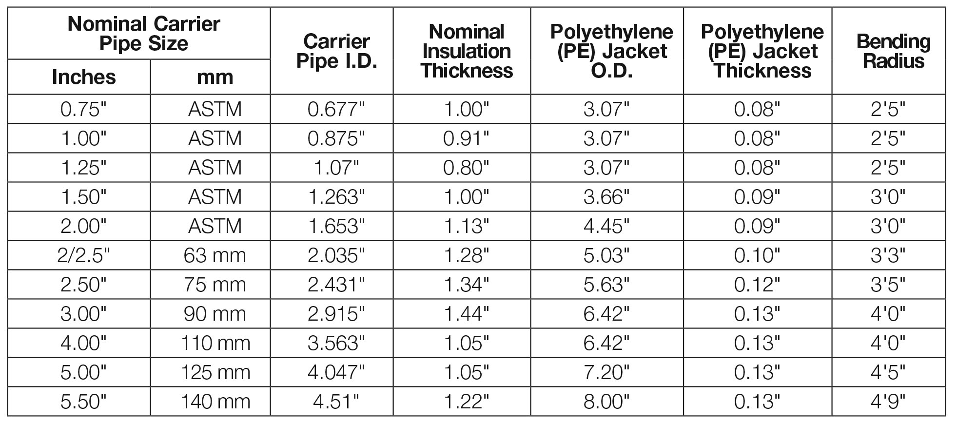

2.04 Joining Method: PEX pipe is joined with compression couplings, or brass Press-Fit fittings conforming to ASTM D-1869. Coupling joints can be field insulated.
Fittings can be insulated or uninsulated depending on owners preference
2.05 Fittings: All fittings are compression type or brass Press-Fit with a positive seal that meets the requirements of ASTM and NSF.
The Brass Press-Fit fittings are certified to ASTM F 1807, the compression nut and sleeve fittings are certified to ASTM F 877, F2080 and CSAB137.5
2.06 Anchors: Pex pipe should be joined to other types of systems with flanges, couplings, threaded adaptors, or soldered copper fittings. All other systems should be anchored within
five feet of connection point to eliminate any thrust, stress or torque from being transferred to
the Pex pipe.
2.07 Approved Vendors: Pre-Insulated Pex Piping System by Rovanco®, Joliet, Illinois. Any alternate supplier must be ISO Certified and submit their technical data to the engineer ten days prior to bid date to be approved in writing as an equal.
*Other types of Pre-Insulated Pipe are also available from Rovanco®.

